**PRACTICAL NO : 02**

**//Perform the steps of Installation active Theme in WordPress**

**Step 1**- Login with WordPress

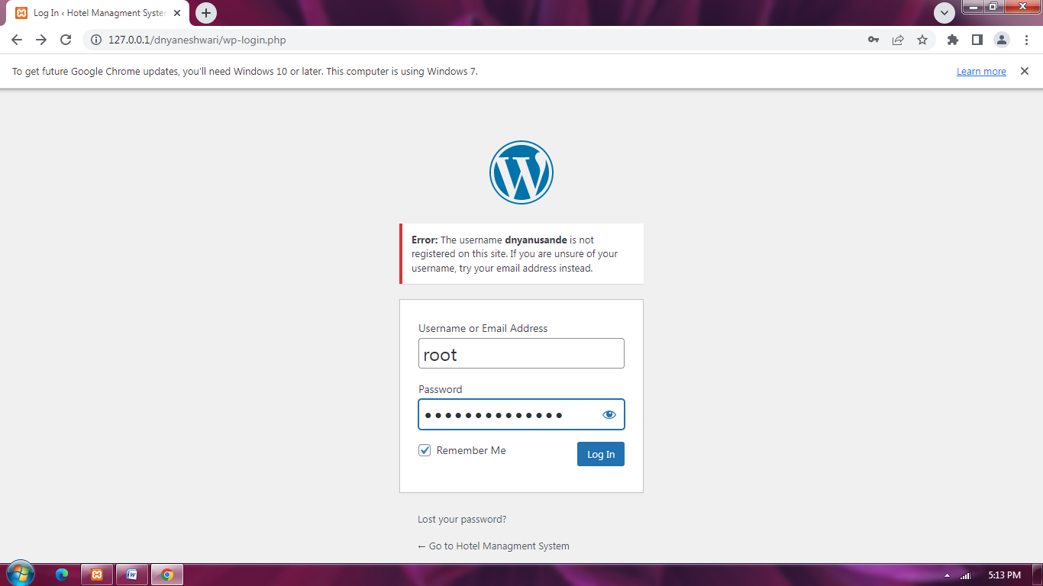

**Step 2-** Navigate to Your WordPress Themes Section

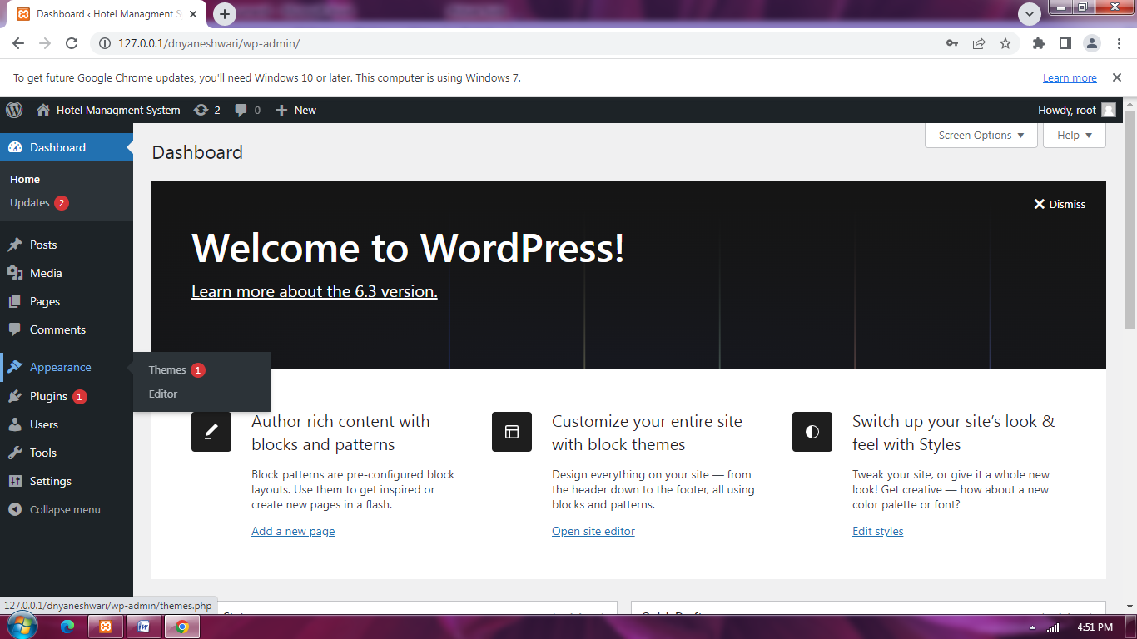

**Step 3**- By Default Themes

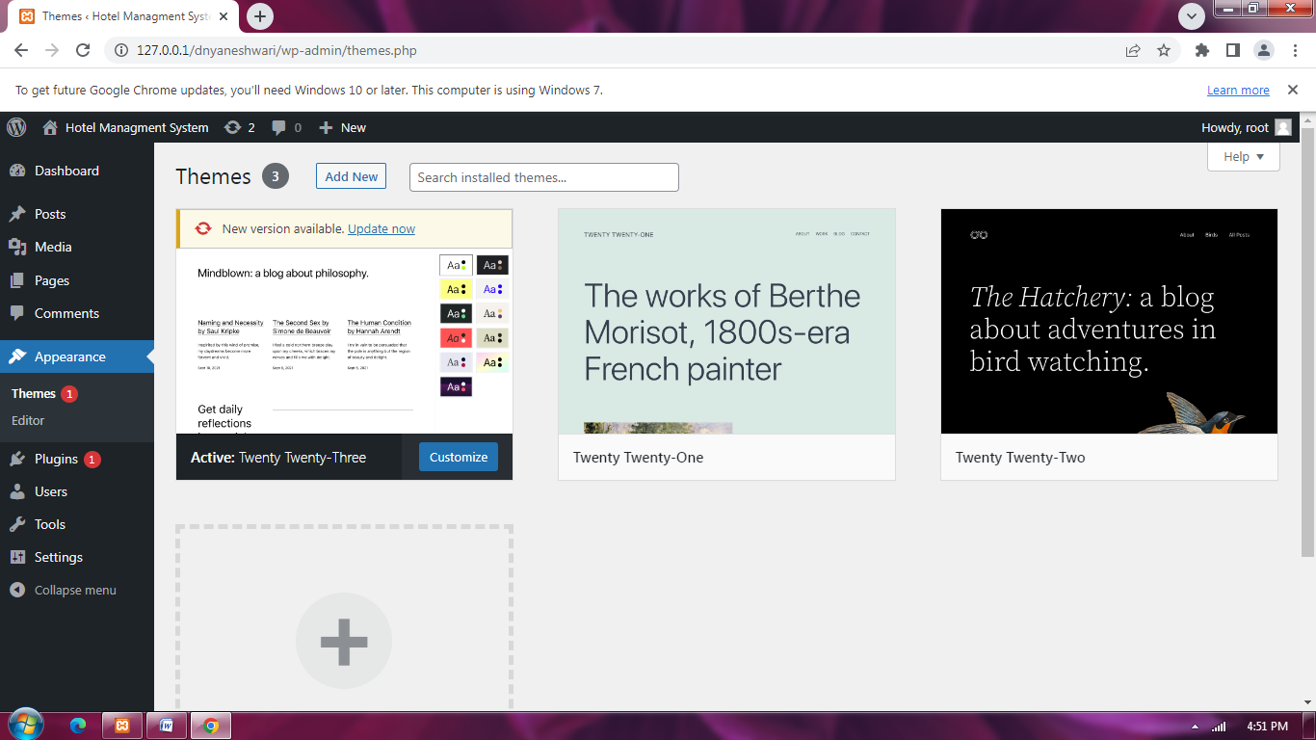

**Step 4**- Inastall Your WordPress Theme

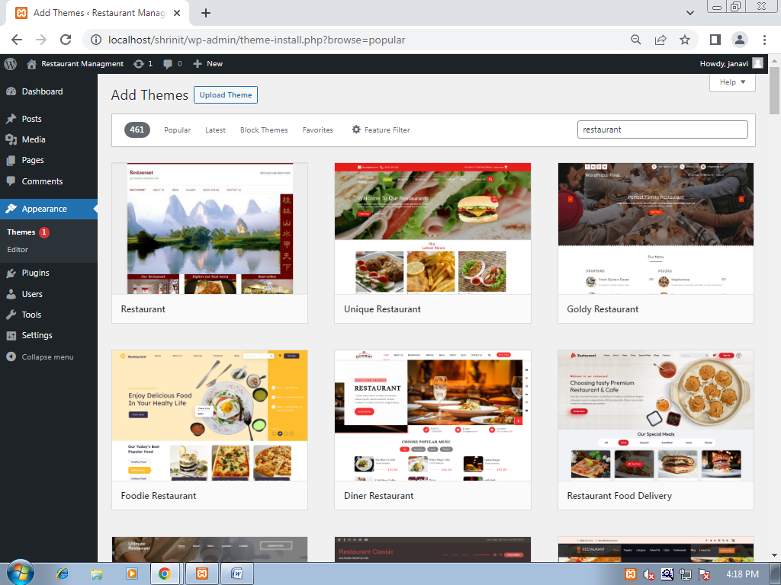

**Step 5** - Activate Your New WordPress Theme

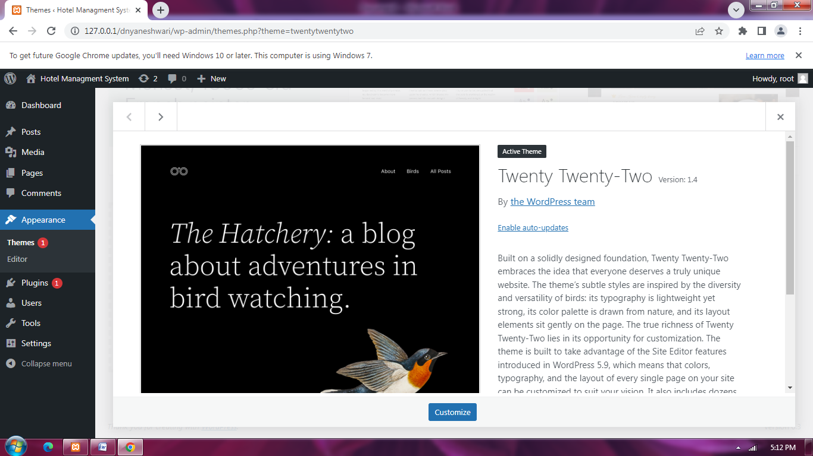

Step 6 - Refresh the page

